WEEK 4 ASSIGNMENT | PRODUCT MANAGEMENT
UX Design & Customer Journey Map
From discovery to purchase and retention: pain points, opportunities and a roadmap to higher conversion for an online fashion & lifestyle marketplace (India)
Prepared by: [Your Name]
Course / Program: [Program Name]
Date: October 2026
Note: The platform analysed ("ShopSphere") is a representative mid-size mobile-first marketplace. Benchmarks come from public research (listed in Section 10) and should be re-verified against the latest editions before external use.

Contents

1. Executive Summary
Online shoppers rarely buy in a straight line. They discover a brand on social media, search, compare, doubt, leave, and return. This document maps that journey for a mobile-first fashion and lifestyle e-commerce platform and finds where customers lose confidence or patience.
Public research is consistent on the biggest leak: roughly 70% of carts are abandoned, mainly because of surprise costs, forced account creation, slow delivery, and low trust at payment. In India, the picture also includes cash-on-delivery (COD) preference, UPI-first payments, size uncertainty and costly returns.
Key findings
- Biggest leak: The deepest emotional dip is in the Purchase stage, where shipping fees appear late and account creation is forced just as intent peaks.
- Hidden driver: Size/fit doubt and weak social proof on the product page drive comparison-shopping and exits in Consideration.
- Retention lever: Returns and refunds decide whether a customer buys again. A smooth return can be a retention tool.
Headline recommendations
- Show total price early, offer guest checkout and phone-OTP login, and cut form fields.
- Add a fit assistant, photo reviews and a clear delivery-date promise on product pages.
- Make returns self-serve, with fast refunds to the original source or wallet credit.
- Use behavior-triggered re-engagement (cart, price drop, replenishment) instead of generic blasts.
Targets for a 90-day programme: checkout completion +15 to 20%, cart abandonment down 8 to 10 percentage points, return rate down 10%, and 90-day repeat-purchase rate up 20%. These are planning targets to be validated through A/B tests.

2. Scope, Methodology and Persona

2.1 Approach
The work followed five steps, aligned to the assignment brief:
- Stages: Defined four journey stages: Awareness, Consideration, Purchase and Retention.
- Research: Collected publicly available insights (Baymard Institute, Google/Think with Google, Nielsen Norman Group, Statista, McKinsey, Bain, public app-store and forum reviews).
- Persona: Built a persona and a scenario to keep the map grounded in one realistic user.
- Mapping: Plotted actions, thoughts, emotions, pain points and opportunities per stage.
- Prioritisation: Prioritised fixes by impact and effort, and defined KPIs and experiments.

2.2 Primary Persona
Attribute | Description
Name / Age | Riya Sharma, 27
Location / Role | Delhi NCR; marketing executive, works hybrid
Devices | Android smartphone (90% of browsing), laptop for occasional bigger purchases
Goals | Find stylish, reasonably priced workwear and festive outfits; get the right size first time; receive it before an event
Behaviours | Discovers on Instagram; checks 2-3 competitor sites; reads reviews and looks for customer photos; prefers UPI, sometimes COD for new sites
Frustrations | Surprise delivery charges, size inconsistency, being forced to register, unclear return terms, slow refunds
Quote | "I'll buy today if I know the final price, the size will fit, and I can return it easily."

Scenario: Riya has a cousin's wedding in three weeks. She wants a festive kurta set under Rs 3,000 that arrives within a week.

3. Journey Overview
The journey is shown in four stages. In practice, customers loop between Consideration and Awareness (retargeting) and between Retention and Consideration (repeat purchase).
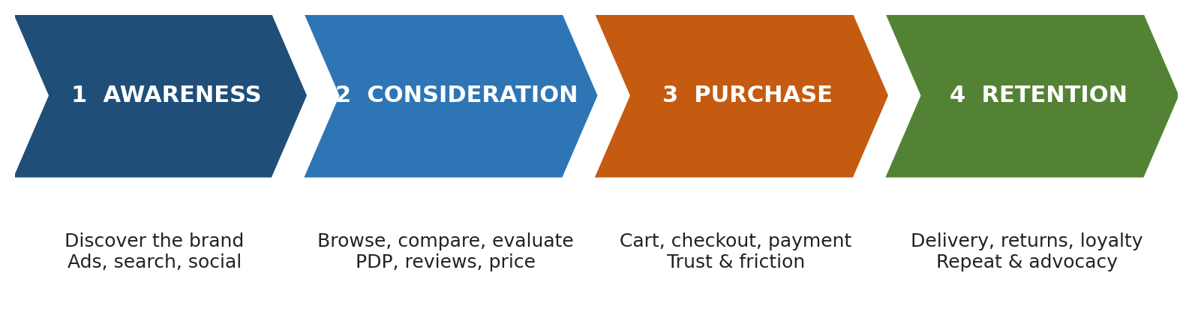
Figure 1: The four critical stages of the e-commerce customer journey
Stage | Customer goal | Key touchpoints | Decision influence
Awareness | Find out who sells what I need | Instagram/YouTube ads, influencers, Google search, marketplace listings, word of mouth | Brand credibility, relevance, first-load speed
Consideration | Decide if this is the right product and seller | Home page, category and search, filters, product page, reviews, size guide, competitor sites, WhatsApp/Email nudges | Price clarity, fit confidence, reviews, delivery estimate, returns policy
Purchase | Pay quickly and safely | Cart, login/signup, address, shipping options, payment, OTP, confirmation page | Total cost, trust, speed, payment options
Retention | Receive it, fix issues, buy again | Order tracking, SMS/WhatsApp updates, delivery, returns portal, support chat, loyalty, email/push | Delivery reliability, return ease, support quality, personalised offers

4. Detailed Customer Journey Map
Table 1 summarises customer interactions, thoughts and emotions at each stage for the Riya persona.
 | 1. AWARENESS | 2. CONSIDERATION | 3. PURCHASE | 4. RETENTION
Customer goals | Discover options for a festive outfit  Check if the brand looks credible | Shortlist 2-3 outfits  Confirm fit, quality and value | Pay the exact expected price  Finish fast with a safe method | Receive on time  Easy exchange/refund  Find new things to buy
Touchpoints | Instagram reel ad  Google search, Shopping results  Friend's recommendation | Home, category, filter and sort  Product page, size chart, reviews  Wishlist, competitor tabs | Cart, login, address form  Delivery options, coupon, payment gateway/OTP | Order SMS/WhatsApp, tracking  Delivery agent, returns portal  Support chat, email/push
Customer actions | Taps ad, scrolls feed  Searches "festive kurta set under 3000" | Applies filters, opens 6 product pages  Zooms into photos, scans reviews, compares prices | Adds to cart, reviews total  Registers, enters address, selects payment, enters OTP | Tracks parcel, tries outfit  Raises return if size is off  Opens (or ignores) re-engagement messages
Thoughts / questions | "Nice, but who is this seller?"  "Will the page load fast?" | "Which size am I?"  "Are these photos real?"  "Is it cheaper elsewhere?" | "Why is there a delivery fee now?"  "Why do I need an account?"  "Is this payment safe?" | "Will it arrive before the wedding?"  "Is the refund going to be a hassle?"  "Would I shop here again?"
Emotion | Curious / Positive (+1) | Uncertain / Mixed (-0.5) | Frustrated at fees and sign-up (-1.9), relieved at confirmation (+1.8) | Anxious waiting, delighted on delivery (+1.5), annoyed if return is hard (-1)
Pain points | Slow mobile load (3s+ loses visitors)  Ad-to-landing mismatch  Low brand trust signals | No fit guidance, inconsistent sizing  Few photo reviews  Cluttered filters, poor search relevance  Unclear delivery date | Surprise shipping/tax costs  Forced account creation  Long forms (10+ fields)  Limited payment options, OTP failures  No visible security or returns assurance | Delayed or silent delivery updates  Complicated, slow returns  Refund wait of 7+ days  Generic, repetitive promotions
Opportunities | Landing pages matching ad creative  Page speed budget under 2.5s LCP  Creator content, social proof, UGC | Fit assistant (height/weight/past size)  Photo and video reviews  Smart search with typo tolerance  Delivery date by pincode | Total price shown from cart  Guest checkout + phone-OTP  Autofill, pincode lookup, 5-field address  UPI intent, COD, EMI, wallets, retry flow  Trust badges, return promise | Proactive WhatsApp tracking  Self-serve returns with pickup scheduling  Instant refund/credit  Behaviour-based lifecycle messages, loyalty tiers
KPIs | CTR, bounce rate, CAC, LCP | PDP-to-cart rate, search exit rate, review engagement | Checkout completion, cart abandonment, payment success | On-time delivery %, return rate, NPS/CSAT, 90-day repeat rate

5. Emotional Journey
The curve below plots how Riya feels at 15 key moments. The two lowest points (shipping fee reveal and forced account creation) happen at the moment of highest purchase intent, which is why they matter so much for conversion.
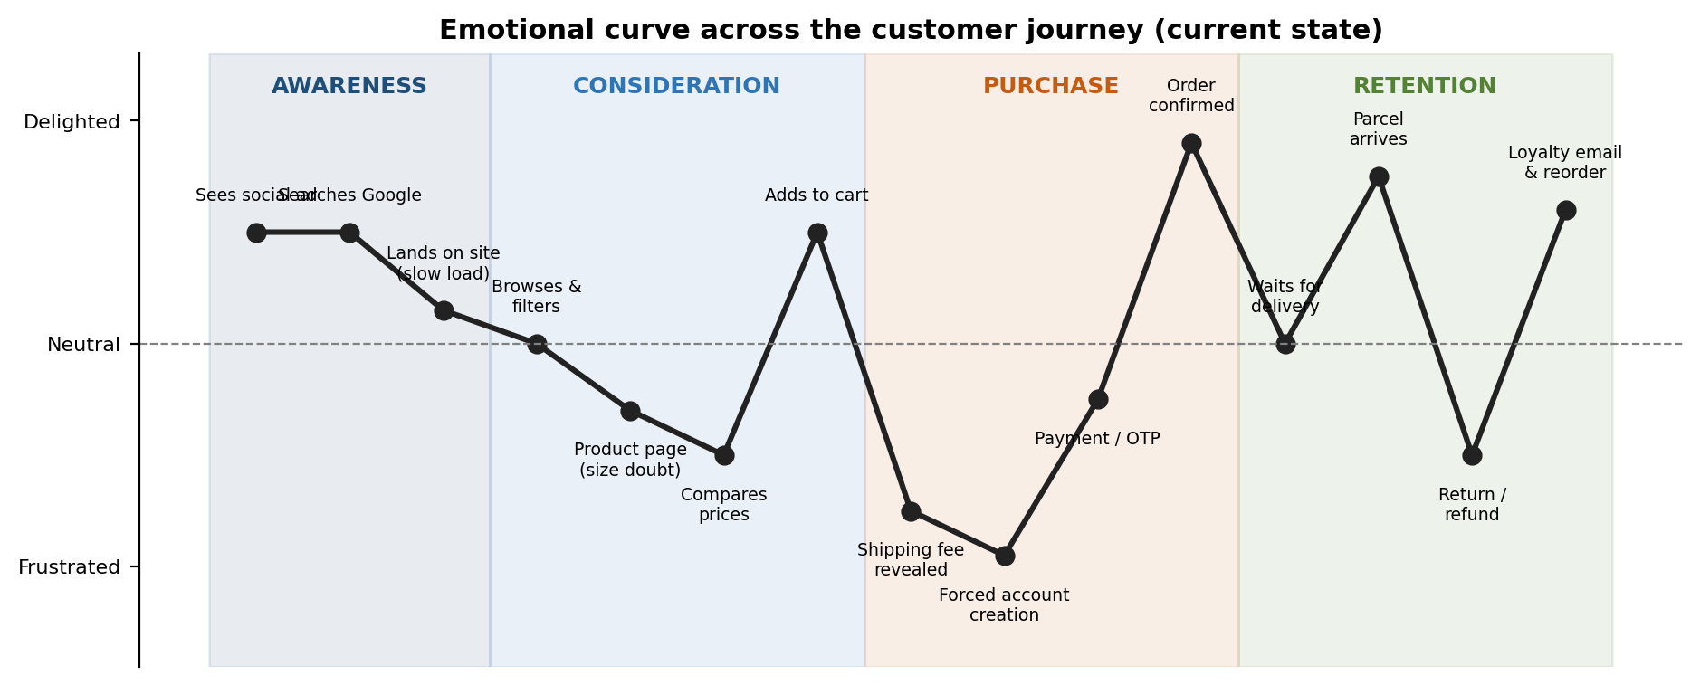
Figure 2: Emotional curve across the journey (illustrative, based on persona walkthrough and public research)
How to read it: peaks (order confirmation, parcel arrival) are the moments to reinforce and ask for reviews or referrals. Valleys are the moments to fix, since each one is an exit point.

6. Pain-Point Analysis and Proposed Solutions
Pain points are drawn from public research and typical user feedback. Each is matched with a practical solution and the metric that will show whether it worked.

6.1 Awareness
Pain point | Evidence / public insight | Proposed solution
Slow mobile pages | Google research reports that around 53% of mobile visits are abandoned if a page takes over 3 seconds to load | Compress images (WebP/AVIF), lazy-load, CDN, set a speed budget (LCP under 2.5s); track Core Web Vitals
Ad-to-landing mismatch | Common cause of high bounce rates; users expect to land on the product or collection they saw | Deep-link ads to the exact collection; carry over offer and creative
Low trust in unfamiliar brands | Shoppers check reviews and policies before first purchase | Show ratings, return policy, delivery promise and creator/customer photos above the fold

6.2 Consideration
Pain point | Evidence / public insight | Proposed solution
Size and fit uncertainty | Fit is a leading reason for apparel returns; Indian sizing varies across brands | Fit assistant using height/weight/past purchases; "runs small/large" tags from reviews; model measurements
Weak social proof | Baymard and NN/g find users rely on reviews and customer photos to judge quality | Photo/video reviews, review filters by size and body type, verified-buyer badge
Poor search and filtering | NN/g reports many sites fail common search queries (synonyms, typos) | Typo-tolerant search, auto-suggest, simple filter chips, saved filters
Unclear delivery timing | Delivery speed is a top-five abandonment reason in Baymard studies | Pincode checker on product page with an exact delivery date
Price comparison exits | Shoppers open competitor tabs when value is unclear | Price-match messaging, bundle offers, low-stock cues (honest, not manipulative), wishlist price-drop alerts

6.3 Purchase
Pain point | Evidence / public insight | Proposed solution
Extra costs at checkout | Baymard: extra costs (shipping, tax, fees) are the top abandonment reason, cited by about 48% of shoppers | Show total including delivery in the cart; free-shipping progress bar; no new fees after cart
Forced account creation | Baymard: about 26% abandon when forced to create an account | Guest checkout; phone-OTP quick login; create account after purchase
Long or complex checkout | Baymard: around 22% cite a too long or complicated process; average checkouts have many more fields than needed | Reduce to 5-6 fields, pincode auto-fill, address autocomplete, progress indicator, single-page flow on mobile
Trust and payment issues | About 25% say they did not trust the site with card details; OTP failures common in India | Security badges, UPI intent/QR, saved cards (tokenised), automatic retry and alternative-method prompts on failure
Limited payment options | Preference varies: UPI, COD, cards, EMI, wallets | Offer UPI, cards, wallets, EMI and verified COD with small fee/transparent rules

6.4 Retention
Pain point | Evidence / public insight | Proposed solution
Delivery delays and silence | Delivery experience strongly influences repeat purchase intent | Proactive WhatsApp/SMS updates, live tracking, delay compensation voucher
Complicated returns | Baymard and retail studies show a clear returns policy affects purchase confidence; difficult returns reduce repurchase | Self-serve returns in 3 taps, pickup scheduling, exchange-first option, instant status tracking
Slow refunds | Refund delays are a frequent complaint in public app-store reviews | Instant refund to wallet/credit with bonus; 48-hour refund SLA to original source
Generic communication | Bain reports that a 5% increase in retention can lift profits by 25-95%; relevance matters | Behaviour-triggered journeys: abandoned cart, back-in-stock, replenishment, post-purchase review ask, tiered loyalty

7. UX Improvement Proposals (Visual Concept)
Figure 3 sketches the highest-impact change: redesigning the mobile checkout. The "before" flow hides costs, forces registration and asks for too much input. The "after" flow removes each of these barriers.
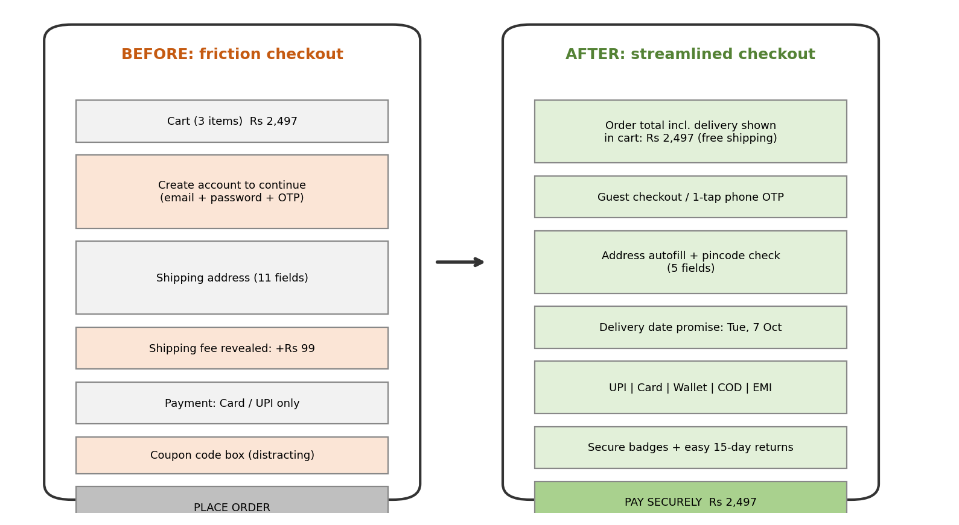
Figure 3: Low-fidelity wireframe, current vs proposed mobile checkout

7.1 Other Key Screens (described)
- Product page: Large photo carousel, then price and delivery date by pincode, then size selector with "Find my size" button, rating summary with photo reviews, and a sticky Add-to-Cart bar. Return policy shown in one line under the CTA.
- Cart: Always-visible total, free-shipping progress bar, saved-for-later, and "complete the look" suggestions. Coupons are applied automatically when eligible.
- Order tracking: Order timeline (placed, packed, shipped, out for delivery), live map, one-tap "Need help" and "Return/Exchange" buttons, and a delivery-date promise.
- Returns flow: Select item, select reason, choose pickup slot, choose refund method; each step shows how long the refund will take.

8. Prioritisation, Roadmap and Measurement

8.1 Impact vs Effort
Initiative | Impact | Effort | Priority / rationale
Show total price early; remove surprise fees | High | Low | Quick win: addresses the #1 abandonment reason
Guest checkout + phone-OTP login | High | Low-Med | Quick win: removes forced registration
Shorten address form + autofill | High | Medium | Do next: improves mobile completion
Pincode delivery-date promise | High | Medium | Do next: builds confidence in Consideration
Photo reviews + fit tags | High | Medium | Do next: reduces doubt and returns
Self-serve returns + fast refunds | High | High | Strategic: major retention driver
Fit assistant | Medium-High | High | Strategic: long-term return-rate reduction
Page speed programme | Medium-High | Medium | Do next: lifts every stage
Behaviour-triggered messaging | Medium | Medium | Do next: lowers cost to re-engage
Loyalty tiers | Medium | High | Later: after retention basics are fixed

8.2 Phased Roadmap
Phase | Timeline | Deliverables
Phase 1: Quick wins | Weeks 1-4 | Total price in cart, guest checkout, phone-OTP, payment retry, trust badges, cart-abandonment messages
Phase 2: Core experience | Weeks 5-10 | Short address form with autofill, delivery-date by pincode, photo reviews, search improvements, performance budget
Phase 3: Retention | Weeks 11-16 | Self-serve returns, refund SLA, proactive tracking updates, loyalty pilot, fit assistant (beta)

8.3 KPIs and Experiments
Stage | Primary KPI | Baseline (assumed) | 90-day target
Awareness | Bounce rate on landing pages | 55% | 45%
Consideration | PDP-to-cart rate | 7% | 9%
Purchase | Checkout completion; abandonment | 30%; 70% | 36%; 61%
Retention | Return rate; 90-day repeat rate | 28%; 18% | 25%; 22%

Each change should be validated with an A/B test (control vs variant), a minimum sample size set in advance, and guardrail metrics (average order value, payment failure rate, support tickets). Qualitative checks (5-8 usability sessions per stage and session recordings) should accompany the quantitative data. Baselines above are assumptions for illustration and should be replaced with the platform's own analytics.

9. Conclusion
The journey map shows that conversion is lost less because of product or price and more because of avoidable friction: unclear total cost, forced registration, fit doubt, and uncertain returns. These problems are fixable, and many fixes are low-effort. By addressing the Purchase stage first, building confidence in Consideration, and treating returns and delivery as retention tools, the platform can improve conversion, satisfaction and repeat purchases together.
A user-centric product manager treats each valley in the emotional curve as a hypothesis to test, and each peak as a moment to build loyalty.

10. References and Public Sources
The following publicly available sources informed the analysis. Figures are cited from their published findings and should be re-checked against the latest versions.
- Baymard Institute: Cart Abandonment Rate Statistics and Checkout Usability research (reasons for abandonment, average abandonment around 70%).
- Google / Think with Google: Mobile page speed benchmarks (53% abandonment beyond 3 seconds).
- Nielsen Norman Group: E-commerce UX, site search and product page usability articles.
- Bain & Company / Frederick Reichheld: Retention economics (5% retention increase and profit impact).
- McKinsey & Company: Customer journey and personalisation research.
- Statista and public industry reports: India online shopping, UPI and COD payment trends.
- Public app-store reviews and consumer forums for leading Indian fashion and general marketplaces: qualitative pain-point themes.
- Shopify, Salesforce and Klaviyo public blogs: e-commerce lifecycle messaging and returns practices.

